September 2018

Editorial

Not only at today’s forefront, Alfa Laval is securing future flexibility with Alfa Laval PureSOx

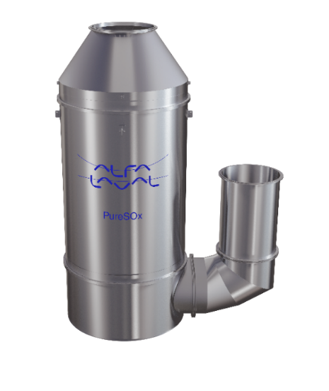

Image name
PureSOx_U_design.jpg

Caption
Alfa Laval PureSOx

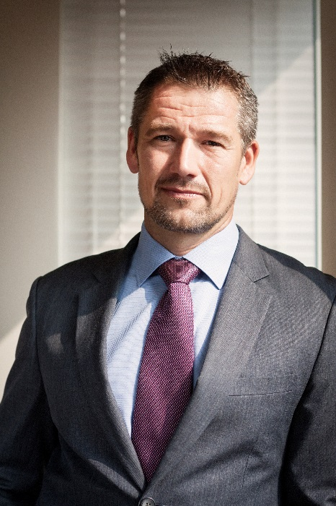
Image name
Erik_Haveman_Sales_Director_Exhaust_Gas_Cleaning.jpg

Caption
Erik Haveman, Sales Director Exhaust Gas Cleaning at Alfa Laval

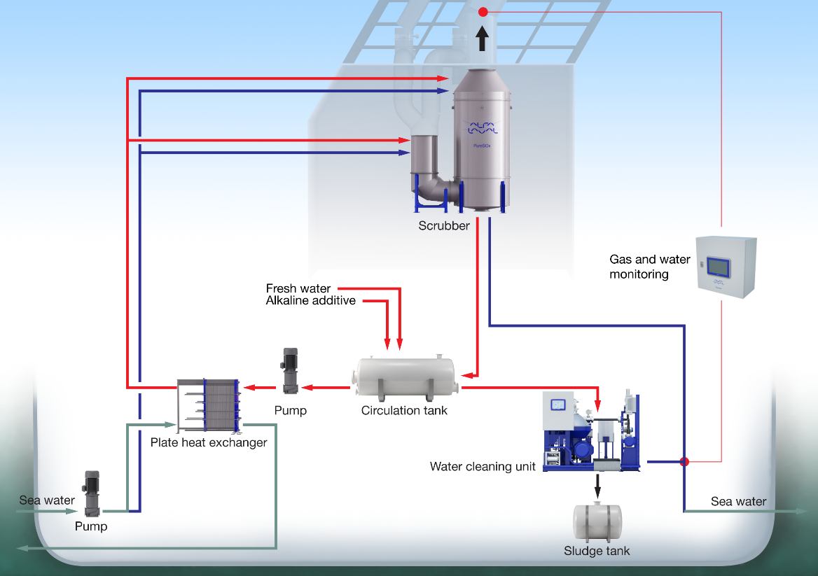

Image name
PureSOx_Hybrid_U-design_System.jpg

Caption
Alfa Laval PureSOx configurations

