Consultant specification sheet
Gasketed plate heat exchanger
General specifications:
- Supplier of the plate heat exchanger is Alfa Laval or equivalent.
- Supplier shall provide 2 and 3D drawings and instruction manuals in local language, for each heat exchanger.
- All heat exchangers shall be produced in production facilities that are environmentally certified according to ISO 14001.
- All heat exchangers shall be tested with test pressure before delivery. Test sequence shall be 30 minutes on each side. Both sides shall be tested.

Frame specifications:
- Frame plate shall have flange stud bolts or threaded pipes assembled around the connections.
- External threaded pipe connections shall not be welded on to the frame plate.
- Frame and pressure plate shall have side slot tilted bolt hole geometry (not holes in frame) to allow small footprint, easier and safer maintenance.
- Click for video
- Frame and pressure plate, tightening bolts/nuts and pipe connections shall be market with charge number for full traceability.
- Frame and pressure plate shall have lifting holes in the upper corners.
- The unit should have feet supplied for fixing at front and back.
- For 150 mm connection and above:
  - The main tightening bolts shall have bearing boxes to support easy opening and closing of the heat exchanger. Click for video
  - Pressure plate shall have Stainless Steel roller sliding on the carrying bar to enable easy opening and closing. Click for video
  - The tightening bolts shall have lock washers to support easy opening and closing by one person. Click for video
  - The tightening bolts shall have fixed bolt head. Click for video
  - The tightening bolts shall have plastic cover over the threads. Click for video

Plate specific details:
- Plate material in contact with fluids on hot and cold sides shall be in alloy 316 or alloy 304. For sea water installations titanium plates shall be used.
- Each plate shall have an efficient flow distribution area, to maximise use of pumping power for efficient heat transfer. This will help reduce the heat transfer area installed and avoid dead spots for longer operation life time. Click for video
- All plates shall be single step pressed to secure uniform thickness, have no weak spots and give accurate seating of gasket in the gasket groove. This enables the plate pack to better handle pressure shocks, vibrations, plate fatigue, high operating pressures and high differential pressures. Click for video
- The plates shall not have holes for attaching of the gasket
- All plates shall be market with a charge number for full traceability
- Fluid inlet and outlet connections should be positioned in parallel on the frame plate and not diagonal to allow ease of installation.
- All plates are being washed after pressing to avoid greasy plates reducing heat transfer.
- For 150 mm connection and above:
  - Each plate shall have a built in five point alignment system to accurately locate the plates in the frame assembly to prevent lateral plate movement under pressure. Five point alignments also give superior sealing throughout the plate pack and make closing of the heat exchanger after service easier. Click for video

Gasket specifications:
- Gaskets must not be glued on the plate.
- Gasket material to be NBR for temperatures of 120 °C and below, EPDM for 150 °C and below.
- All gaskets shall be locked into the groove
- Gaskets shall have a roof top or ribbed top cross section design to ensure superior sealing performance.
- Gasket profile tailored to fit the plate type and thickness – longer lifetime of gaskets and plates. Click for video
- All gaskets shall be marked with a colour code for identification of gasket material from the outside of an assembled plate heat exchanger.

AHRI specification:
- The plate heat exchangers shall be AHRI-certified in accordance with the AHRI Liquid to Liquid Heat Exchangers Certification Program. The PHE specifications as selected, shall be verified and registered by AHRI before purchase”

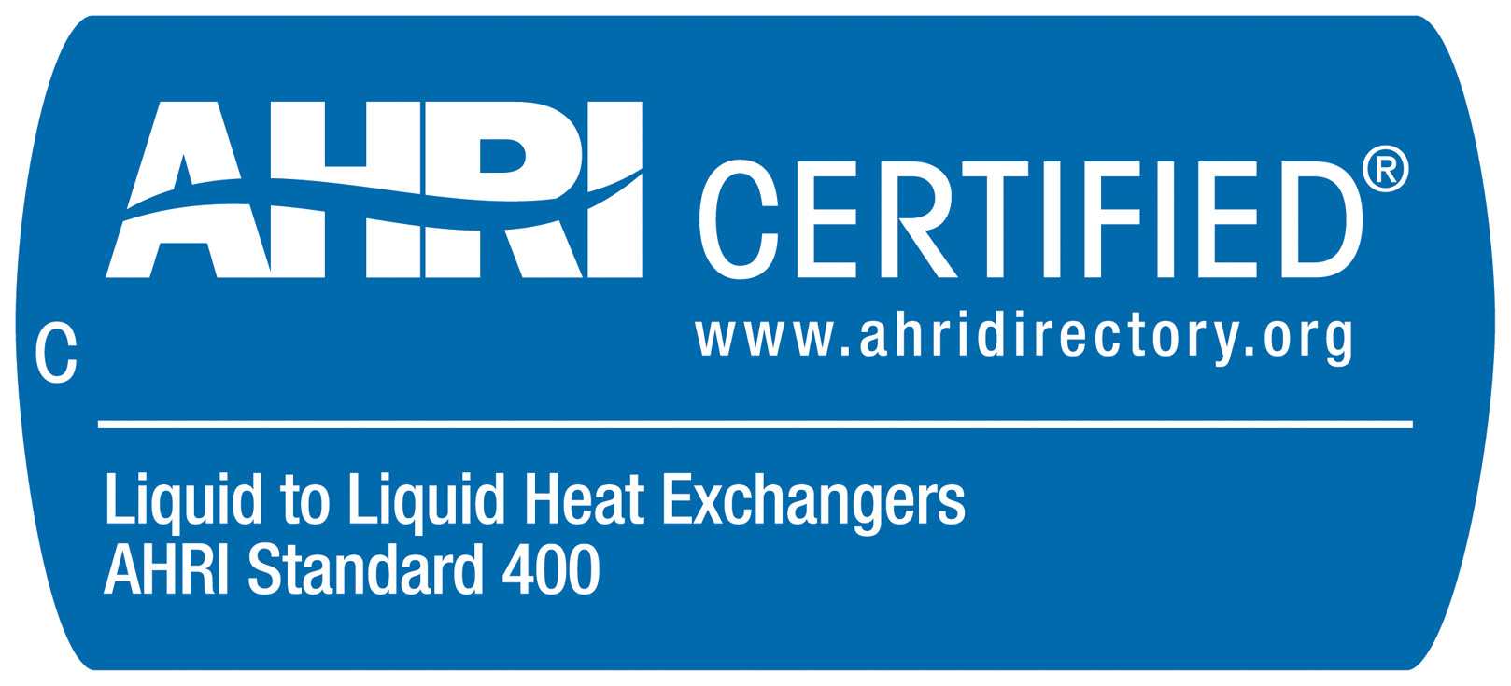

http://www.ahrinet.org

