Image overview

Computer-based training for Alfa Laval PureBallast 3 will help secure crew competence – and ballast water treatment compliance
July 2018

Press Release

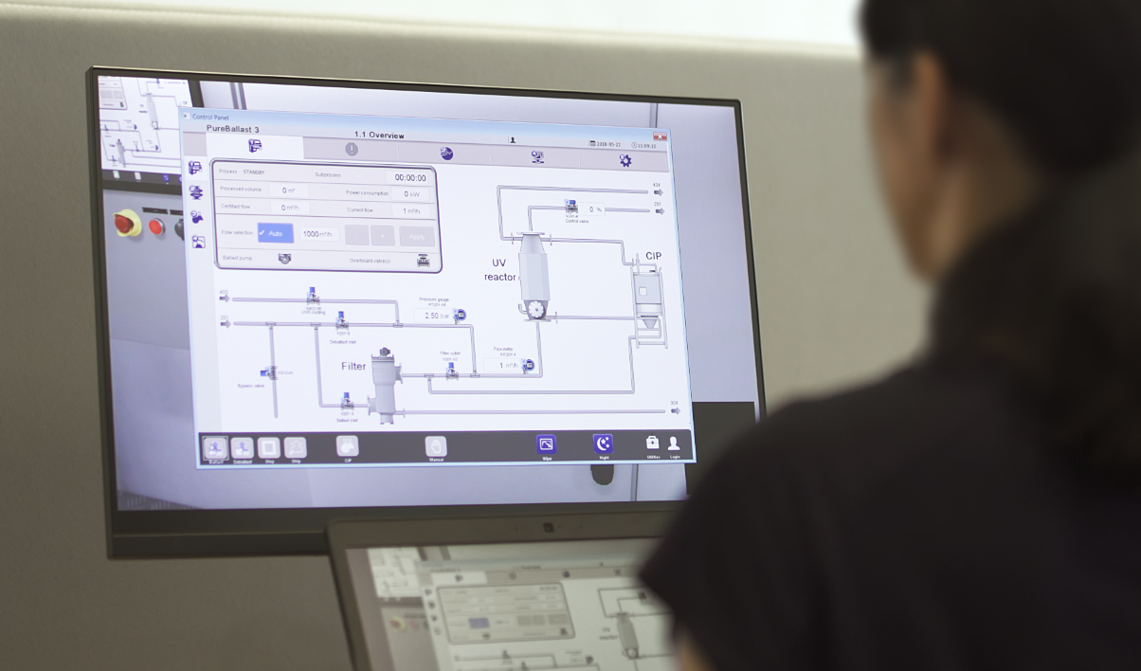

Caption
PureBallast Computer Based training

Image name
CBT.jpg

Alfa Laval is a trademark registered and owned by Alfa Laval Corporate AB. Alfa Laval reserves the right to change specifications without prior notification.

