Image overview

Alfa Laval and customers – together for vessel performance at Nor-Shipping
May 2019

Press Release

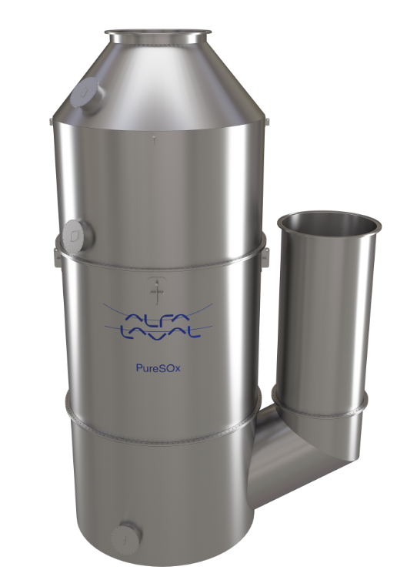

Caption
Alfa Laval PureSox
Image name
PureSOx_Utype_4_0.jpg

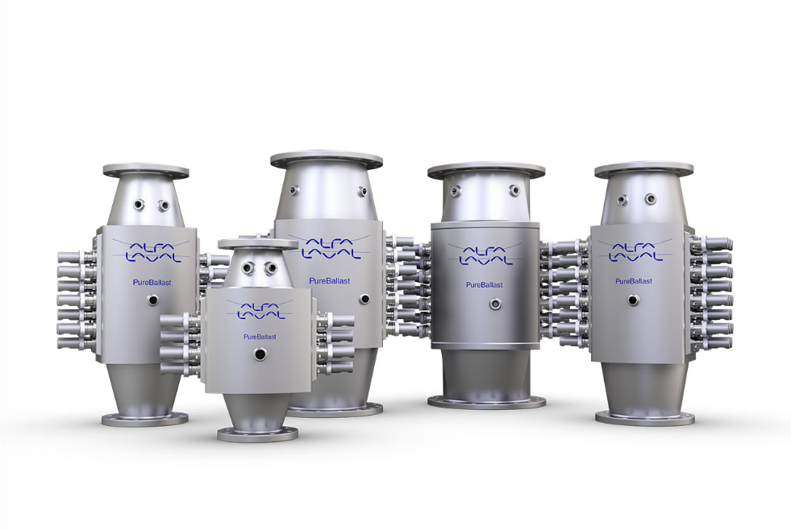
Caption
Alfa Laval PureBallast 3 reactor family
Image name
PureBallast_reactor_family.jpg

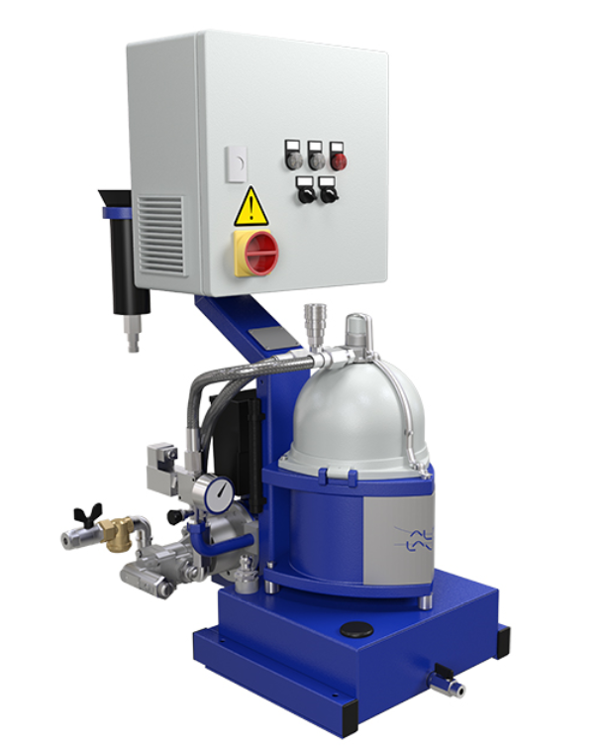
Caption
Alfa Laval MIB 503
Image name
mib 503.jpg

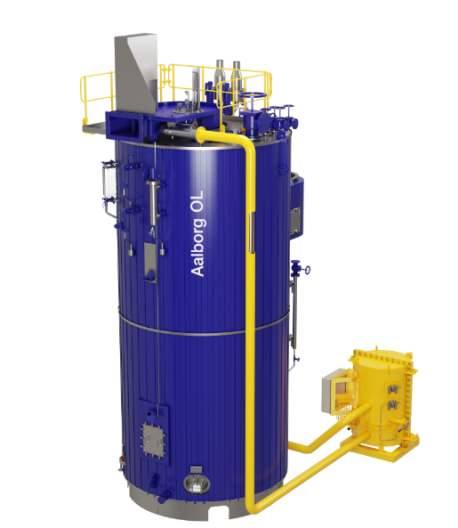

Caption

Alfa Laval Aalborg OL - Multi-fuel boiler solution
Image name
Aalborg OL multi fuel.jpg

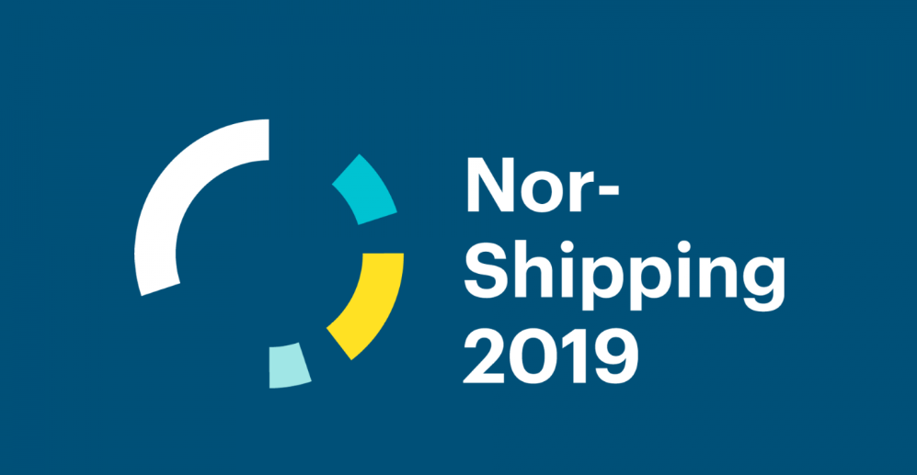

Caption
Nor-Shipping 2019 logo
Image name
Norshipping logo.jpg

Alfa Laval is a trademark registered and owned by Alfa Laval Corporate AB. Alfa Laval reserves the right to change specifications without prior notification.

