Image overview

April 2019

Press release

Alfa Laval PureBallast 3 is now type approved by the U.S. Coast Guard with minimized holding time

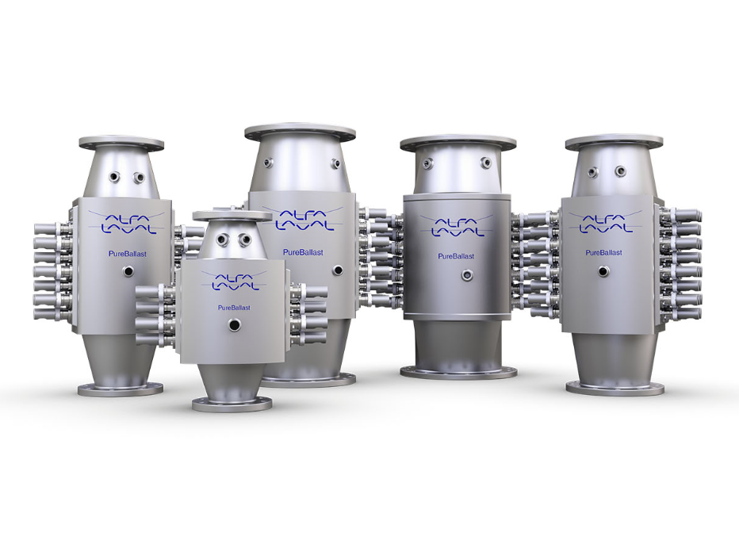

Image name
PureBallast_reactor_family2_shadow.jpg

Caption
Alfa Laval PureBallast 3 reactor family
page 2/2

Image name
PureBallast_Minimized HoldingTime_150min

Caption
Alfa Laval PureBallast 3 Minimized Holding Time

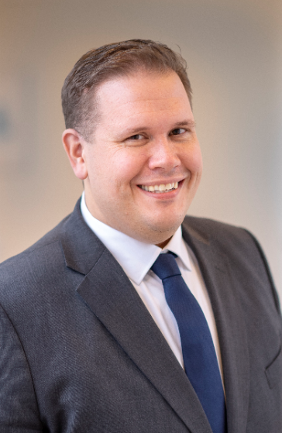

Image name
Anders Lindmark Alfa Laval.jpg

Caption
Anders Lindmark, Head of Alfa Laval PureBallast

Contact:
Anja Simonsson
VP Communications Alfa Laval Marine Division
Tel: + 46 708 538927
Email: anja.simonsson@alfalaval.com

