板式换热器
设计技术要求
一般技术要求:
- 板式换热器的供应商应为阿法拉伐或同等品牌.
- 供应商应提供2D和3D设计图纸及中文版产品安装手册
- 所有热交换器均应在符合 ISO 14001 环保认证的生产设施中生产
- 所有换热器在交付前均应进行压力测试， 测试顺序应为每侧 30 分钟，两侧均应进行测试。

框架板技术要求:
- Frame plate shall have flange stud bolts or threaded pipes assembled around the connections.
- 框架板须在接口处安装带有螺栓的法兰或螺纹管
- External threaded pipe connections shall not be welded on to the frame plate.
- 外螺纹管不得焊接在框架板上
- Frame and pressure plate shall have side slot tilted bolt hole geometry (not holes in frame) to allow small footprint, easier and safer maintenance.
- 框架和压力板两侧应具有几何形状的倾斜的螺栓孔槽（不得在框架板上直接开孔），以便实现小尺寸、更轻松、更安全的维护点击查看视频
- Frame and pressure plate, tightening bolts/nuts and pipe connections shall be market with charge number for full traceability.
- 框架和压力板、紧固螺栓/螺母和管道连接应具有连接编号，可完全可追溯。
- Frame and pressure plate shall have lifting holes in the upper corners.
- 框架和压力板的上角应有吊装孔。
- The unit should have feet supplied for fixing at front and back.
- 装置应提供地脚，用于在前面和后面固定
- For 150 mm connection and above:
- 对于接口在150mm及以上的型号
  - The main tightening bolts shall have bearing boxes to support easy opening and closing of the heat exchanger. Click for video
  - 主紧固螺栓应具有轴承箱，以支持热交换器的轻松打开和回装。点击查看视频
  - Pressure plate shall have Stainless Steel roller sliding on the carrying bar to enable easy opening and closing. Click for video
  - 压力板在承载杆上应具有不锈钢滚轮滑动，以便轻松打开和回装。点击查看视频
  - The tightening bolts shall have lock washers to support easy opening and closing by one person. Click for video
  - 紧固螺栓应具有锁紧式紧固器，以支持一个人轻松打开和回装。点击查看视频
  - The tightening bolts shall have fixed bolt head. Click for video
  - 紧固螺栓应具有固定螺栓头。点击查看视频
  - The tightening bolts shall have plastic cover over the threads. Click for video
  - 紧固螺栓在螺纹上应有塑料覆盖。点击查看视频
板片技术要求
- Plate material in contact with fluids on hot and cold sides shall be in alloy 316 or alloy 304. For sea water installations titanium plates shall be used.
- 与冷热两侧流体接触的板材材料应为不锈钢316或不锈钢304。对于海水装置，应使用钛板。
- Each plate shall have an efficient flow distribution area, to maximise use of pumping power for efficient heat transfer. This will help reduce the heat transfer area installed and avoid dead spots for longer operation life time. Click for video
- 每个板具有高效的流量分配区域，以最大限度地利用泵送功率实现有效的传热。这将有助于减少换热面积，避免死水区，延长使用寿命。点击查看视频
- All plates shall be single step pressed to secure uniform thickness, have no weak spots and give accurate seating of gasket in the gasket groove. This enables the plate pack to better handle pressure shocks, vibrations, plate fatigue, high operating pressures and high differential pressures. Click for video
- 所有板应为一次性压制，以确保均匀的厚度，没有弱点，并给出垫片槽中垫片的精确位置。这使得板片组能够更好地处理压力冲击、振动、板片疲劳、高工作压力和高差压。点击查看视频
- The plates shall not have holes for attaching of the gasket
- 板片上不得有用于连接垫片的孔
- All plates shall be marked with a charge number for full traceability
- 所有板片应具有标号并具备可追溯性
- Fluid inlet and outlet connections should be positioned in parallel on the frame plate and not diagonal to allow ease of installation.
- 流体入口和出口连接应平行放置在框架板上，而不是对角线，以便于安装
- All plates are being washed after pressing to avoid greasy plates reducing heat transfer.
- 所有板在压制成型后都进行清洗，以避免油污导致降低传热
- For 150 mm connection and above:
- 对于接口尺寸在150mm及以上型号：
  - Each plate shall have a built in five point alignment system to accurately locate the plates in the frame assembly to prevent lateral plate movement under pressure. Five point alignments also give superior sealing throughout the plate pack and make closing of the heat exchanger after service easier. Click for video
  - 每张板片具有内置的五点对齐系统，以准确定位框架组件中的板，以防止在压力下横向板移动。五点对齐还可在整个板包中提供卓越的密封，使维修后热交换器的关闭更加容易。点击查看视频

垫片技术要求
- Gaskets must not be glued on the plate.
- 垫片不得粘在板片。
- Gasket material to be NBR for temperatures of 120 °C and below, EPDM for 150 °C and below.
- 垫片材料为 NBR，温度为 120°C 及以下，EPDM 为 150°C 及以下。
- All gaskets shall be locked into the groove
- 所有垫片应锁定在凹槽中
- Gaskets shall have a roof top or ribbed top cross section design to ensure superior sealing performance.
- 垫片应具有屋脊或带肋顶的横截面设计，以确保卓越的密封性能。
- Gasket profile tailored to fit the plate type and thickness – longer lifetime of gaskets and plates. Click for video
- 为适合板材类型和厚度而定制的垫片轮廓 – 垫片和板的使用寿命更长。点击查看视频
- All gaskets shall be marked with a colour code for identification of gasket material from the outside of an assembled plate heat exchanger.
- 所有外部垫片均应标有颜色代码，用于识别组装板热交换器的垫片材料。

AHRI specification:
AHRI技术要求：
- The plate heat exchangers shall be AHRI-certified in accordance with the AHRI Liquid to Liquid Heat Exchangers Certification Program. The PHE specifications as selected, shall be verified and registered by AHRI before purchase”
- 根据 AHRI 液体到液体换热器认证计划，板式换热器应经过 AHRI 认证。所选的板式换热器 规格应在购买前由 AHRI 进行验证和注册"

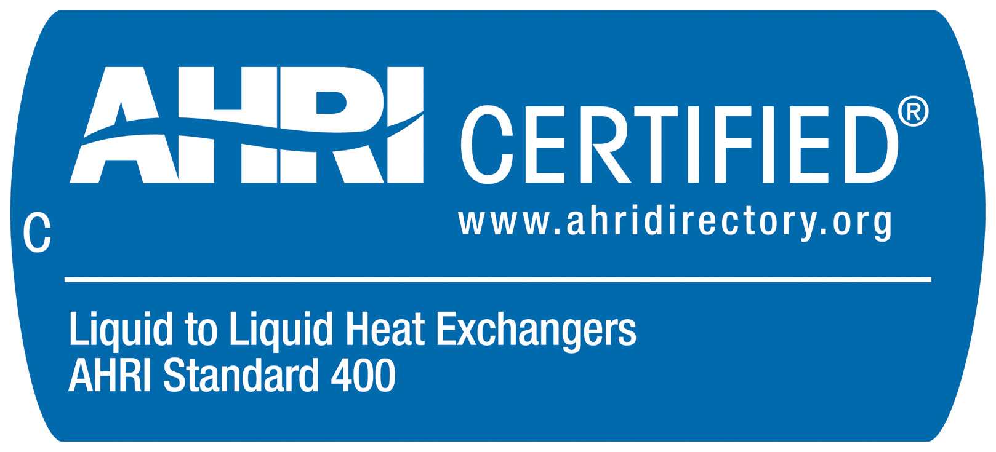

http://www.ahrinet.org

