To:
收件人：
From:
发件人：
Subject:
主题：

Plate corrugations
板片波纹
One of the biggest changes manufacturers have made to the gasketed plate heat exchanger (GPHE) technology in recent years is the design of the plate corrugations. The corrugations are what control flow distribution and turbulence within the unit. There is a dead spot on most plates that is prone to fouling and where heat transfer is poor. See attached screen shot at the bottom of the email - red circles. Alfa Laval has redesigned the corrugations and port on the plate to eliminate this dead spot. Recapturing this dead space and turning it into effective heat transfer area means you can use fewer plates. The corrugations also produce more turbulence, which means a higher heat transfer coefficient and less surface area required. In some cases, this new plate design will allow you to reduce the surface area by 20% when compared to the original unit.
近年来，制造商对垫片板式换热器（GPHE）技术的最大改变之一就是板片波纹的设计。板片波纹控制换热器内部流体分配和湍流。大多数板上都有盲区，容易结垢，且传热不佳。参见邮件结尾所附截图中的红色圆圈。为消除这类盲区，阿法拉伐重新设计了新型波纹和角孔型式。利用该盲区并将其转化为有效传热区域意味着可以减少板片的数量。更佳的波纹也会产生更强湍流，可提高传热系数，减少所需的换热面积。某些情况下，这种新型的板型设计可实现换热面积相比过去节约20%。
Here is an animation on the CurveFlow: https://www.youtube.com/watch?v=TxiG3Y0Pnqk
CurveFlow的动画演示见https://www.youtube.com/watch?v=TxiG3Y0Pnqk

Alfa Laval uses two different corrugation patterns per model - high and low theta - which describes the angle of the "V" on the plates. Think of the V (theta) as a speed bump. The more obtuse angle is the high theta plate and will provide more resistance to the fluid. The more acute angle is the low theta and will provide less resistance. Unless we are dealing with a viscous fluid where a mixed plate pack could negatively affect flow distribution, we mix the two types of plates to optimize both U-value and dP.
阿法拉伐在每个型号上使用两种不同的波纹形式——不同 “V” 形的角度意味这高低不同的传热单元数，可视为影响流动状态的因素。高传热单元数板上为钝角波纹，产生的流体阻力大。低传热单元数板上为锐角波纹，产生的流体阻力小。除此以外我们还可以组合两种角度板型以处理一些粘性流体从而平衡优化合理的传热系数和压力降。

AHRI
Alfa Laval takes pride in the quality of its designs. We are more conservative than most manufactures. In the mid-late 90's we became heavily involved in AHRI, which is a third-party certification of GPHEs. AHRI takes a manufacture's design software and tests a sampling of their GPHEs against the algorithms for heat transfer and differential pressure. You pass if you are within 95% of the predicted heat load and 115% of the predicted differential pressure. Alfa Laval designs to zero tolerance - always. Many mfgs do not - they will take advantage of the tolerances that AHRI allows. AHRI eliminates the games that mfgs play. We strongly recommend AHRI certification for Mission Critical designs.
阿法拉伐以优异设计为荣。相比大多数制造商，我们更加保守。90年代中后期，我们开始大量使用板式换热器第三方认证即AHRI认证。AHRI备案制造商设计软件，并实验测试换热器样品的传热系数和压力降。验证结果的允许偏差热负荷在95%以内和压力降115%以内则为合格。阿法拉伐坚持零偏差，而许多制造商则利用AHRI所允许的允许偏差。AHRI终结了制造商可能的违规行为，因此我们强烈建议对关键工况设计进行AHRI认证。

Features and benefits
特征和优点
Many of the other changes that Alfa Laval has made allow the GPHE to be serviced more easily/effectively.
阿法拉伐做出的许多设计革新使得板式换热器的维修更加简单/高效。
•• ClipGrip gaskets - the gaskets do not tangle as easily and are less cumbersome to install/replace
ClipGrip垫圈 - 垫圈不易缠结，安装/更换更加简单
•• Swing feet - simpler to pull PHE and less prone to jamming - https://www.youtube.com/watch?v=sKDDeLQz9FI
旋转地脚 - 更容易移动板式换热器端板，不易卡住 - https://www.youtube.com/watch?v=sKDDeLQz9FI
•• Roller bar on the pressure plate - https://www.youtube.com/watch?v=qTG3sfsGOUw
压紧板上的滑动滚轴 - https://www.youtube.com/watch?v=qTG3sfsGOUw
•• Five-point alignment system - https://www.youtube.com/watch?v=SPJvl4A0xFQ
五点定位系统 - https://www.youtube.com/watch?v=SPJvl4A0xFQ
•• Bearing boxes on tightening bolts - https://www.youtube.com/watch?v=xiDKpU72TMY
夹紧螺栓上的轴承盒 - https://www.youtube.com/watch?v=xiDKpU72TMY

Optional features
选配件
•• Insulation to reduce condensation on the exterior of the unit.
保温材料，以减少机组外部冷凝。
•• Port filter for poor water quality. Requires inspection ports on frame plate.
角孔段过滤器，改善水质。要求框架板上设有检查口。
•• Cleaning in Place (CIP) - portable cleaning module.
在线清洗（CIP）- 便携式清洗模块.

Best design practices
最佳设计实践
Turbulence - The performance of a plate and frame heat exchanger (heat transfer and fouling resistance) is dependent upon the level of turbulence achieved within the unit. The transition from laminar flow to turbulent flow occurs at a Reynolds number of 2200; the Reynolds number is directly proportional to the fluid velocity. The fluid velocity through the channel is calculated by dividing the flow rate through the hxr by the cross section of the "pipe" or size of the plate pack. If you increase the cross section of the "pipe" (add plates or units in parallel), at a constant flow, your velocity will decrease, therefore your turbulence will also decrease. If your turbulence decreases, your heat transfer coefficient and wall shear stress (see Fouling) will suffer. Many folks believe that throwing additional surface area at the hxr will provide them with a safety buffer, but the opposite occurs b/c it affects the turbulence.
湍流 - 板式换热器的性能（传热和防垢）取决于板片间流体的湍流水平。雷诺数为2200时层流变为湍流；雷诺数与流体速度成正比。板间流量除以通道的横截面积可得流体板间速度。如流量不变，通道的横截面积（增加板片或并联设备）增加，流速将降低，湍流将减小。若湍流降低，传热系数和壁面剪应力（见结垢）将下降。许多人认为可通过增加板片数可为其提供可靠性，但由于湍流受到影响，反而适得其反。

Fouling - We do not use fouling factors. A traditional fouling factor of 0.0005 will increase the surface area by approximately 35%, which per the above explanation, will decrease the channel velocity. In one example, this additional 35% took what would have been a U-value of 1100 Btu/ft²-hr-F and reduced it to 700 Btu/ft²-hr-F. If you must have excess area, use 10%. If fouling is a concern, the more important parameter to maintain is wall shear stress. Wall shear stress is the force the fluid exerts on the plate to keep particulates suspended in the stream and is directly proportional to the dP. The target wall shear stress for a fouling application = 50 Pa, min 35 Pa. We can usually achieve 50 Pa with a dP of ~10 psi. As a secondary defence against fouling, we recommend using some type of filtration. The mesh on the filter should be ~75% of the open channel spacing.
结垢 - 我们不使用污垢系数。传统的污垢系数0.0005将增加约35%的表面积，如上所述，这将降低板件流速。在一个示例中，增加的35%的表面积取代了1100 Btu/ft²-hr-F的U值，并将其减少到700 Btu/ft²-hr-F。如果必须增加面积，可增加10%。如果结垢是个问题，更为重要的是保持壁面剪应力这个参数不变。壁面剪应力是流体施加在板上使颗粒悬浮在水流中的力，与压降成正比。对于易结垢应用建议壁面剪应力=50 Pa，最小35 Pa。通常可以得到50 Pa，对应压降约为70kpa。作为防止结垢的第二道防线，我们建议使用过滤器。过滤器上的网孔应约为开槽间距的75%。

Temperature approach - The last couple tenths of a degree are exponentially more difficult to achieve. If you can open up the approach even 0.1-0.2°F, you can greatly reduce the surface area required.
温度差 - 最后十分之几度极其难以达到。如果能够减少温差，即使是0.1-0.2°F，也可以大大减少所需表面积。

Connection velocity - Target connection velocity = 8-10 ft/s, up to ~15 ft/s for a retrofit (like pipe velocity). If you are comparing GPHE bids and one mfg is quoting a 6" connection and another is quoting an 8" connection, you should inquire about the connection velocity, which takes me to the next topic - %dP lost in the connections.
接口流速 - 目标接口流速2.4-3 m/s，对于改装机组，最高可达约4.57 m/s（如管道速度）。如果您正在对比不同换热器投标产品，一个制造商报6"的接口，另一个报8"的接口，您应该询问接口流速，这就要讨论下一个话题——接口压力损失的百分比。

% of dP lost in the connections - dP is your driving force. If you take too much dP to get the fluid through the connection and to the first plate, you will not have enough driving force to push the liquid through the entirety of the plate pack, effectively cutting your surface area by X. To ensure proper plate pack distribution, limit %dP lost in connections to 30-35% of total dP across the heat exchanger.
接口压力损失的百分比 – 压损是驱动力。如果使流体通过接头到达第一个板耗费过大的压损，则没有足够的驱动力推动流体通过整个板组，并有效地将表面积减少。为确保流体在角孔段的均匀分配，将接口压力损失限制在整个换热器总压损的30-35%。

Minimum plate thickness - This is driven by how the mfg presses its plates and the required design pressure. Master specification states that plates material must be 0.0254" before pressing. This is b/c many mfgs press in multiple stages, leading to thin spots on the plate. Alfa Laval presses its plates in a single stage so does not need this extra tolerance. For most HVAC cooling applications 0.4 mm plates are more than adequate for a 150 psi design pressure.
最小板厚 - 这取决于制造商的压板方式和所需的设计压力。一些规范规定，压制前板材须为0.64mm。这是因为很多制造商分段压制，导致板上易出现薄弱点。阿法拉伐一次性压制，所以不需要这一额外允差。对于大多数暖通空调冷却应用，0.4 mm板对于10.3bar的设计压力是足够的。

Try to put as much info on the schedule as possible: heat load, surface area, LMTD, dP, %dP lost in the connections, connection velocity, wall shear stress, weight, dimensions etc.
参数表上的信息应尽可能详尽，包括热负荷、表面积、LMTD、dP、接口处dP损失%、接口流速 、壁面剪应力、重量、尺寸等。

We respect that many end users wish to standardize on a single design. Doing so can unfortunately create operational as well as maintenance issues. GPHEs will transfer heat regardless of the operating conditions, however they are designed to perform optimally at one set of conditions. When the heat exchanger is operated outside of these conditions, the potential for problems begins to increase, primarily fouling. This is not to say that GPHEs cannot handle fluctuating operating conditions, only that we must be fully aware of how the heat exchangers will be used so that we can analyse all scenarios and provide you with the best solution.
我们尊重许多终端用户希望将单一设计标准化的选择，但这样会造成运行和维护问题。换热器传热功能不受运行条件影响，然而它的设计是为了在一定条件下实现最佳性能。当换热器超出这些运行条件时，会增加出现问题的风险，主要是结垢。这并不是说换热器不能应对变化的运行条件，只是我们必须充分了解换热器的使用方法，以便分析所有可能出现的情况，并为您提供最佳的解决方案。

Alfa Laval Insight features and movies
阿法拉伐洞察力特征和影像
For the offered gasketed plate heat exchangers we would like to take the opportunity to highlight some of the key features of our products.
对于所提供的垫圈板式换热器，我们想在此重点说明我们产品的一些重要功能。

Frame related features
框架相关特征
Bearing box
轴承箱
•• Ball bearing inside – reduce frication
螺栓减阻轴承 – 减少摩擦
•• Possible to open and close GPHE on 4 tightening bolts only (6 on large GPHEs)
只需4个紧固主螺栓打开和关闭换热器（大型换热器上有6个）
•• Faster maintenance – reduced maintenance cost
快速维修 – 降低维修成本
•• Less risk of paint damage on frame plate – reduce spare cost
框板上油漆损坏的风险更低 – 降低备件成本

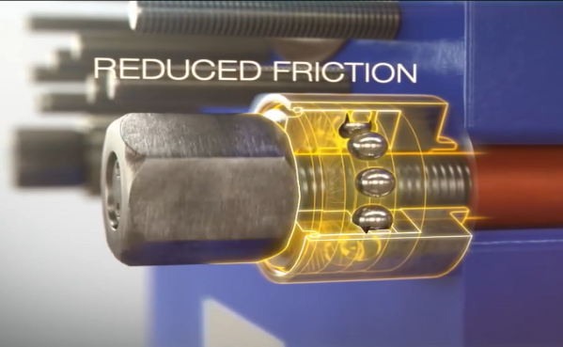
摩擦减小
Figure 1 Click on Picture to see movie
图1点击图片观看视频

Elongated nuts
加长螺母
•• Reduced risk of overheating and seizure of nut
降低螺母过热和卡住的风险
•• Trouble free service
可靠服务
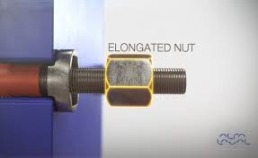
加长螺母
点击图片观看视频

Click on Picture to see movie

Fixed bolt head
固定螺栓头
•• Bolt is fixed to tightening bolt under any condition
螺栓始终固定在紧固螺栓上
•• Trouble free service
可靠服务
•• Safe to do service
服务安全
•• Glued designs are less reliable
胶合设计不太可靠
Click on Picture to see movie
点击图片观看视频

Key holt bolt opening
侧取螺栓
•• Smaller foot print including service area
占地面积更小，包括服务区域
•• Faster service – reduced maintenance cost
服务更快 – 降低维护成本
•• Bolt holes closed from the side are standard on some other manufacturers GPHEs
从侧面封闭的螺栓孔是一些其他制造商GPHE的标准配置
Click on Picture to see movie
点击图片观看视频
Lock washer
锁紧垫圈
•• The tightening bolt can be opened & closed from one side (no rotation)
紧固螺栓可从一侧打开和关闭（无需额外锁住另一头）
•• Faster maintenance – reduced maintenance costs
快速维修 – 降低维修成本
•• Reduces risk that the tightening bolts fall out –safety
降低紧固螺栓脱落的风险 – 安全
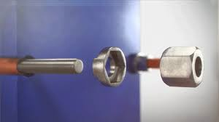
•• Many other manufacturers deliver the bolts with standard flat washer
许多其他制造商提供带有标准平垫圈的螺栓
Click on Picture to see movie
点击图片观看视频

Pressure plate roller
压紧板滚轴
•• High quality steel – reduced risk of corrosion
优质钢材 – 降低锈蚀风险
•• Steel and not plastic – reduced risk of breakdown
钢、非塑料 – 降低故障风险
•• Faster service – reduced maintenance cost
服务更快 – 降低维护成本
•• Many other manufacturers rollers corrode
许多其他制造商的滚筒会锈蚀
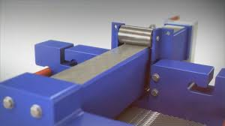
Click on Picture to see movie
点击图片观看视频

Pressure plate roller on T-bar
压力板T型滑轨低位滚轴
•• No corrosion on metal roller or T bar – reduced maintenance cost
金属滚轴及T型滑轨无锈蚀 – 降低维护成本
•• Roller protected under carrying bar
滚轴在托杆下受到保护
•• Fits in areas with limited space because of lower height
由于高度较低，适合安装在受限空间
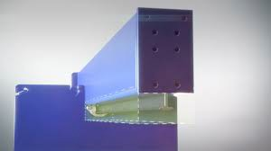
Click on Picture to see movie
点击图片观看视频

Tightening bolt cover
紧固螺栓保护
•• Reduced risk of corrosion & stuck tightening bolts
降低紧固螺栓锈蚀和卡住的风险
•• The nut is locked in the lock washer & the lip prevents it from rotation
螺母紧固在锁紧垫圈中，锁紧垫圈的边缘防止螺母旋转
•• Faster maintenance – reduced maintenance cost
快速维修 – 降低维修成本
•• Longer life time of tightening bolts – reduced spare costs
延长紧固螺栓的使用寿命 – 降低备件成本
•• Many other manufacturers deliver without bolt protection
许多其他制造商交付的产品没有螺栓保护
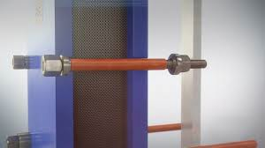
Click on Picture to see movie
点击图片观看视频

Plate related features
板相关特征

Distribution area Chocolate pattern
巧克力形分流区
•• Avoid mal-distribution and fouling build up
避免分布不均和结垢
•• Lowest Possible pressure drop
可能的最低压降
•• Maximization of heat transfer area
传热面积最大化
分布优良
点击图片观看视频
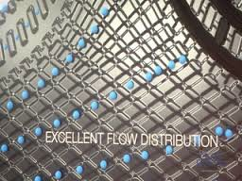
•• Reduced fouling – longer running time
减少结垢 – 运行时间延长

Click on Picture to see movie

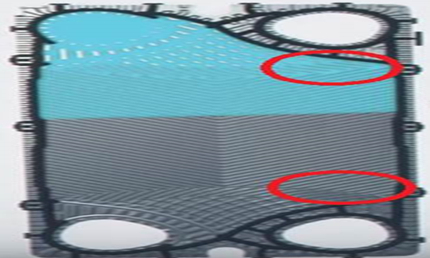

Gasket profile
异形垫圈形状
•• Gasket profile tailored to fit the plate type and thickness – longer lifetime of gaskets and plates
为适应板型和板厚而定制的异形垫圈– 延长了垫圈和板片的寿命
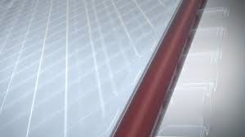
Click on Picture to see movie
点击图片观看视频

Leak chamber
泄漏室
•• Early leak indication – minimize intermixing of fluids
早期泄漏显示 – 尽量减少流体混合
•• Avoids corrosion on plate – reduce spare parts
避免板腐蚀 – 减少备件用量
安全性
Click on Picture to see movie
点击图片观看视频

Reinforced hanger
加固悬挂片
•• Perfect alignment
完全对中
•• To avoid plate damage
避免板损伤
•• Easy to service
维修简便
Click on Picture to see movie
点击图片观看视频

Five-point alignment
五点定位
•• Five contact points between the plate and the carrying and guiding bar.
板与上下导杆之间五个接触点。
•• This system ensures a perfect alignment of the plate pack, and facilitates the retightening of the plates after maintenance
该系统确保了板组的完全对中，便于维修后重新夹紧板片
•• Plates perfectly in place during the critical closing procedure of the plate heat exchanger
板式换热器的临界关闭过程中板片完美定位
•• Exact fit – no snaking or leaks
精确配合 – 无蛇形（扭曲）或泄漏
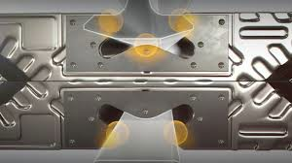
Click on Picture to see movie
点击图片观看视频

