Image overview

Press Editorial February 2016
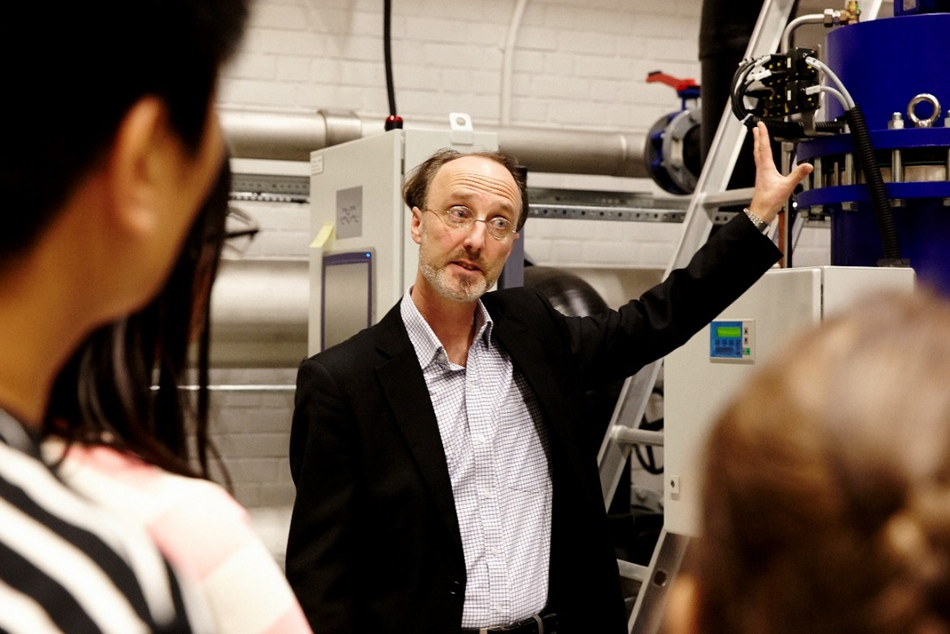
Martin Melin, Technical communicator and trainer, PureBallast.

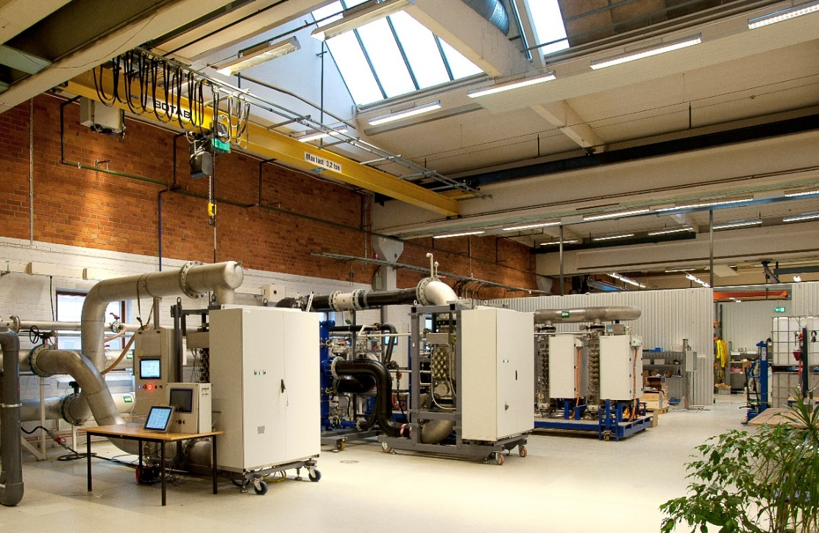
PureBallast Test and Training centre in Tumba, Sweden.

